H. E. KIRIMLI - F. KOÇAK - G. AKKAYA - M.C. HACIİSMAİLOĞLU - Ö. ŞAHİN - A. KILIÇ - A. KAHRAMAN

Ü. A. TARIM - C. S. ÜN - B. KUCUR - K. ŞARLAR - Y. E. FIRAT

UludaĞ UnIversIty FACULTY OF ARTS & SCIENCE  2015

Physics - ı laboratory manual for engineering undergraduates



Contents

0. ERROR ANALYSIS 1

0.1. Error 1

0.2. Absolute Error 1

0.3. Relative Error 2

0.4. Arithmetical Mean 2

0.5. Standart Error in the Mean Value 2

0.6. The Error in a Single Measurement with a Tool 2

0.7. Error in Composite Quantities 2

0.8. Error Calculation in Fundamental Algebra 3

0.9. Calculating Error of a Quantity measured over a Graphic 3

1. VERNIER CALIPER, MICROMETER AND SPHEROMETER 5

2. MOTION IN ONE DIMENSION 10

3. SIMPLE PENDULUM 15

4. ANALYSIS OF A SPRING 20

5. PROJECTILE MOTION 24

6. CONSERVATION OF ENERGY 29

7. CALORIMETER 31

8. MODULUS OF ELASTICITY 34

# 0. ERROR ANALYSIS

## 0.1. Error

All experimentally determined physical quantities contain some degree of error or uncertainty. The error in a measurement is defined as the difference between the measured value and the real value of a physical quantity determined in the experiment.

The numerical value of a measured physical quantity cannot be expressed with its real value due to the experimental errors. The sensitivity and the confidentiality of a measurement are determined with the level of errors, which occur in experiments. An experimental result does not have any scientific meaning unless the error level is provided. Thus, the error, which arises in measurements of the experimental studies, should be determined at each step. There are two kinds of error called systematical and statistical:

## 0.2. Absolute Error

The difference between the real value *X0* and the measured value *X* of a physical quantity is called the absolute error in *X0.*



Since the real value *X0* is not exactly known, the value of *ΔX* cannot be known exactly, but it can be approximately calculated with some methods. The level of absolute error can be determined with the difference between the measured value and the best value that is obtained in all measurements.

## 0.3. Relative Error

The relative error is defined as the ratio of the absolute error, *ΔX*, to the measured value, *X*. Multiplying the relative error by 100 gives the percentage error:



## 0.4. Arithmetical Mean

The values obtained by repeating the same measurements many times form a distribution around a certain value. Such a central value is called “**mean**”.

If *X*1, *X*2, *X*3, … , *X*N are the values obtained in repeating measurements, the arithmetical mean of them



 is the value of *X* in the best approximation. Then, if a quantity is measured *N* times, the mean value can be considered the result of measurements.

## 0.5. Standart Error in the Mean Value

The mean value can be different depending on the distribution of values obtained in a set of measurements. Therefore, the mean value has also a standard deviation and this is called “**standard error**”, which is calculated by



## 0.6. The Error in a Single Measurement with a Tool

In the cases in which it is not possible to repeat measurements, the most appropriate way to determine the error is to take the half of the least amount that can be measured with the tool used in the measurement. For instance, the largest error for a ruler that can measure the least length of 1 mm should be taken as Δ*X*=0.5 mm.

## 0.7. Error in Composite Quantities

If a result depends on various quantities and the error in each of them is known, the total error in the results should be calculated. The standard error in $Q$ is generally calculated as follows:



where  is the partial derivation of *Q* with respect to *x*,  is the partial derivation of *Q* with respect to *y* and  is the partial derivation of *Q* with respect to *z*.

## 0.8. Error Calculation in Fundamental Algebra

* In Addition and Subtraction:



* In Multiplication and Division:



* In Exponential Functions:



* In Trigonometric Functions:

*Q*=sin *x*, if the error in *x* is Δ*x* and *x*, Δ*x* are given in radian



## 0.9. Calculating Error of a Quantity measured over a Graphic



The slope of the line drawn in the graphic can be found by



Following the error calculation in multiplication and division, the error in $R$ can be written as



where Δ(*V*2-*V*1) = Δ*V*2+Δ*V*1 denotes the error in (*V*2-*V*1) and Δ(*I*2-*I*1) = Δ*I*2+Δ*I*1 denotes the error in (*I*2-*I*1). Then the relative error in *R* is obtained by



Determining over the graphic

Δ*V*=Δ*V*2=Δ*V*1 : The measure between two tics next to each other on *V*-axis

Δ*I*=Δ*I*2=Δ*I*1 : The measure between two tics next to each other on *I*-axis

Substituting yields



# 1. VERNIER CALIPER, MICROMETER AND SPHEROMETER

|  |  |
| --- | --- |
| **Equipment :** | Vernier caliper, micrometer, spherometer, iron cylinder, hollow cylinder, iron cube, plastic sphere, watch glass |
| **Purpose :** | * Determination of the length and diameter of several geometric objects (cylinder/cube/prism) with the caliper gauge. * Determination of the radius of spheres with the micrometer. * Determination of the thickness of plates and the radius of curvature of watch glasses with the spherometer. |

**1.1. Experimental Principle**

**1.1.1. Vernier caliper**

The caliper gauge (sliding gauge) is the best known measuring tool for rapid and relatively accurate measurement. Inside and outside diameter and depth measurements can be made. The accuracy which can be achieved is proportional to the graduation of the vernier scale. The measuring faces which are relevant to the taking of reading may be seen in **Fig.1.1.**

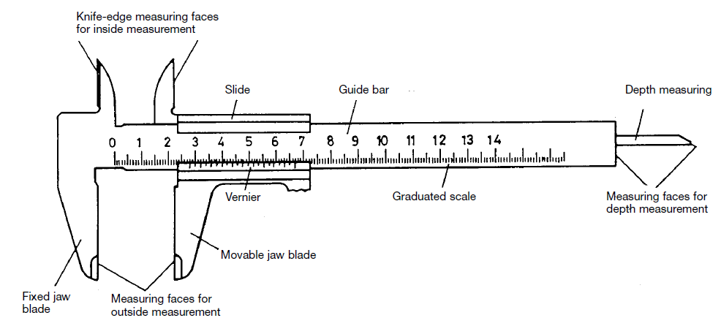

**Figure 1.1.** Vernier Caliper

When the jaws are closed, the vernier zero mark coincides with the zero mark on the scale of the ruler.

The name “vernier” is given to an addition to a gauge which enables the accuracy of measurement (reading accuracy) of the gauge to be increased by 10 to 20 times. The linear vernier is a small ruler which slides along a scale. This ruler is provided with a small scale which is divided into *m* equal divisions. The overall length of these *m* divisions is equal to *m*–1 on the main scale. **Fig.1.2**, enlarged, show 39 divisions extending from 28 mm to 67 mm on the graduated scale, whereas the vernier has 20 divisions (every second mark on the vernier has been omitted).

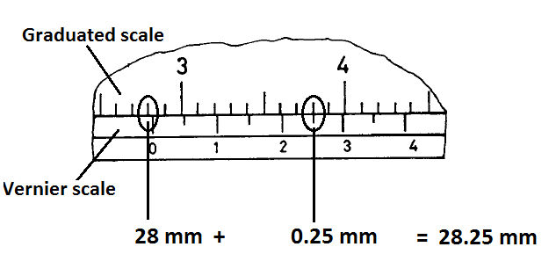

**Figure 1.2.** Reading 28 on the graduated scale and 0.25 on the vernier scale give 28.25 mm

The workpiece to be measured is placed between the measuring faces and the movable jaw blade is then pushed with moderate pressure up against the workpiece. When taking the reading the zero mark of the vernier is regarded as the decimal point which separates the whole numbers from the tenths. The full millimeters are read to the left of the zero mark on the main graduated scale and then, to the right of the zero mark, the vernier division mark which coincides with a division mark on the main scale is looked for. The vernier division mark indicates the tenths of a millimeter **(Fig.1.2).**

**1.1.2. Micrometer**

With the micrometer **(Fig. 1.3)** (micrometer screw gauge) the accuracy of measurement can be increased by one order of magnitude compared to vernier calliper. The workpiece to be measured is placed between the measuring faces, then the measuring spindle is brought up to the workpiece with the rapid drive (ratchet, thumb screw). When the rapid drive rotates idly, the pressure required for measurement has been reached and the value can be read. The whole and half millimeters are read on the scale barrel, the hundredths of millimeters on the micrometer collar, or revolving head which contains 50 divisions, makes the value of the smallest divisions on the head equal to one-fiftieth of 1/2 mm. If the micrometer collar uncovers a half-millimeter, this must be added to the hundredths **(Fig.1.4)**. When the jaws are closed against each other, reading on the scale may not be zero. If so, a correction must be done by adding to or subtracting that value from each scale reading.

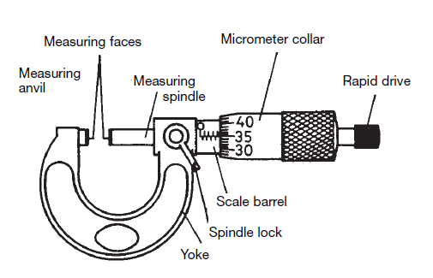

**Figure 1.3.** Micrometer

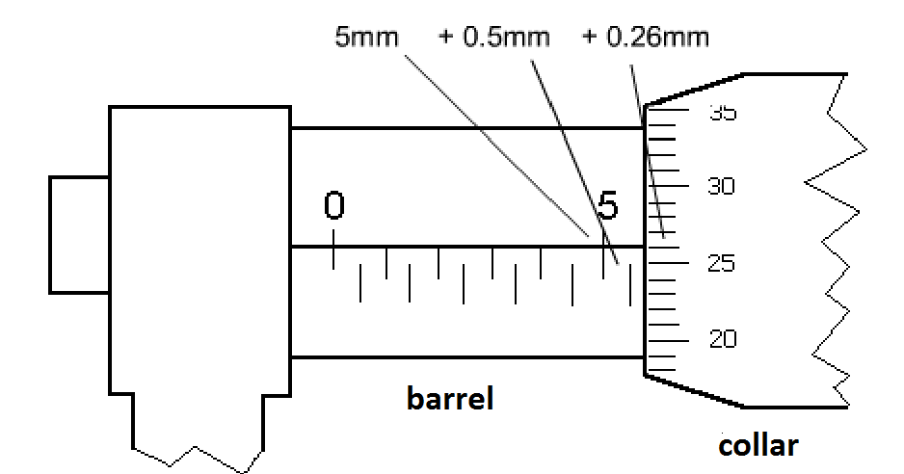

**Figure 1.4.** Reading of 5.76 mm

**1.1.3. Spherometer**

Spherometers are used to measure the thickness of thin objects (plates) or the radius of curvature of objects (spherical surfaces). Its structure and operating principles are similar to those of a micrometer screw. **Fig.1.5.a** shows that, there are two dials for readings of the spherometer, large dial and small dial. One revolution of the large dial corresponds to 1 mm (1 subdivision corresponds to 10-2 mm) and this dial gives the value of *n* in equation below. The number of revolutions (the value of *N* in equation below) is given by the small dial. The maximum measurement displacement is 10 mm. The difference between zero and the value of spherical surface of the glass is calculated by following equation.



To measure the radius of curvature of a spherical surface, firstly, place the three legs (ABC) of the spherometer on the surface, and adjust the screw so that D is in contact with and fixes the surface. If the spherical glass being measured is positioned as shown in **Fig.1.5**, assuming its radius of curvature is *R*, the spherometer is located at points A, B, C, and D, and the tip of the central angle is at D. We assume that *y* is the distance between D and D', which is the center of the equilateral triangle formed by A, B, and C, the sides of Triangle ABC are *a*, and the distances between D' and A, B, and C are all *r*.

Based on the relationship of similar triangles, we obtain;





$$∆(ADD^{'})\sim ∆(EAD')$$

Furthermore, $∆(ABC)$ is an equilateral triangle, the side length of which is *a*; therefore





The measurement accuracy is better than 10-2 mm, depends on the measuring procedure, mainly the moment of contact.

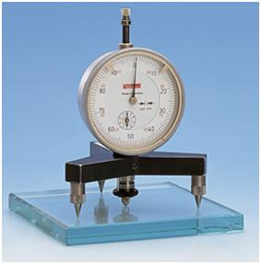

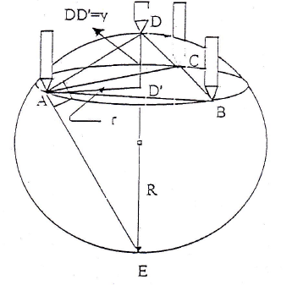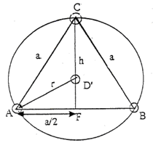

**a)**

**b)**

**c)**

Small dial

Large dial

**Figure 1.5.** Spherometer and experimental design to determine the radius of curvature

**1.2. Experimental Procedure**

1. Using the vernier caliper, measure the length and diameter (*R*=2*r*) of a cylinder and calculate the volume of cylinder. Select a random hollow cylinder and measure its outer and inner diameters and depth, respectively to calculate the volume of the hollow cylinder (including the means and mean standard deviations). To estimate the uncertainties of measurements, make measurements for five times, and calculate the means and mean standard deviations.
2. Measure the diameters (*R*=2*r*) of spheres with the micrometer five times and calculate the volume of these spheres and give results by means and mean standard deviations.
3. Zeroing: Place the spherometer on plate glass and ensure that A, B, C, and D are all contacting the glass. Read the zeros and calculate *y*1. Select a random watch glass, place the spherometer on the spherical surface of the glass, and ensure that the tips of the four legs are in contact with the surface. Read the scale measurement (*y*2). The difference between zero (*y*1) and this value (*y*2) is *y*. Place the four legs of the spherometer on flat paper simultaneous. Apply a little pressure to press the tips to leave marks on the paper. Use these marks to obtain the side length *a* of Equilateral Triangle ABC with vernier caliper. Based on these results, calculate the radius of curvature of the watch glass (*R*). For all measurements calculate mean standard deviations.

# 2. MOTION IN ONE DIMENSION

|  |  |
| --- | --- |
| **Equipment :** |  |
| **Purpose :** | The main purpose of this experiment is to study and analyze:   * The position and velocity of the motion with constant velocity, * The acceleration of a straight-line motion with constant acceleration, * Horizontal projectile (two-dimensional) motion of an object moving on an inclined air table, * Conservation of linear momentum. |

**2.1. Experimental Principle**

**2.1.1. Straight Line Motion with Constant Velocity**

When a particle moves along a straight line, we can describe its position with respect to an origin (O), by means of a coordinate (such as *x*). If there is no net force acting on a moving object, it moves on a straight line with a constant velocity. The particle’s average velocity (*vav*) during a time interval   
(Δ*t* = *t*2 – *t*1) is equal to its displacement (Δ*x* = *x*2 – *x*1) divided by Δ*t*:

$v_{av}=\frac{x_{2}-x_{1}}{t_{2}-t_{1}}=\frac{∆x}{∆t}$ (1)

From the Eq.1, the average velocity is the displacement (Δ*x*) divided by the time interval (Δ*t*) during which the displacement occurs. If we plot a graph *x* versus *t* , then we will have a straight line with a slope. The slope of the line gives the average velocity of the motion.

For a displacement along the *x*-axis, the average velocity (*vav*) of the object is equal to the slope of a line connecting the corresponding points on the graph of position versus time (*x*-*t* graph). The average velocity depends only on the total displacement (*x*) that occurs during the motion time *(t)*. The position, *x(t)* of an object moving in a straight line with constant velocity is given as a function of time as:

$x\left(t\right)=x_{0}+vt$ (2)

If the object is at the origin with the initial position *x*0 = 0, the equation of the motion becomes at any time:

$x\left(t\right)=vt$ (3)

So, the object travels equal distance in the equal time intervals along a straight line (**Fig.2.1**).



**Figure 2.1.** Position as a function of time.

**2.2. Straight Line Motion with a Constant Acceleration**

When a particle slides straight down a frictionless inclined plane, its acceleration is constant, and it will move in a straight line down the plane. The magnitude of the acceleration depends on the angle at which the plane is inclined. If the inclination angle is 90°, the object will slide down with an acceleration which is equal to the Earth’s gravitational acceleration *g* with the magnitude of 9.8 m/s2.

In this experiment, we will observe the motion of a puck moving in a straight line with a velocity changing uniformly. The back side of the air table is raised to form an inclined plane on the air table. The air table is inclined at an angle of *θ* with the horizontal plane as shown in the **Fig.2.2**.



**Figure 2.2.** The straight down motion on an inclined air table.

If you put the puck at the top of the inclined air table and let it slide down the plane, it will move downwards on a straight line but with increasing velocity. The rate of change of the velocity is the acceleration of the puck. If at time *t*1, the puck is at the point *x*1 with a velocity of *v*1, then at a later time *t*2, it will be at a point of *x*2 with a velocity *v*2.

The average acceleration of the puck in this time interval Δ*t* = *t*2 – *t*1 is defined as:

$a_{av}=\frac{∆v}{∆t}= \frac{v_{2}-v_{1}}{t_{2}-t_{1}}$ (4)

Suppose that at an initial time *t*1=0, the puck is at the position of *x*0 and has a velocity of *v*1=*v*0. At a later time *t*2=*t*, it is in position *x* and has a velocity of *v*2=*v*. Then, the average acceleration will be equal to:

$a_{av}= \frac{v-v_{0}}{t-0}$ (5)

Then, the velocity of the puck will be:

$v=v_{0}+at$ (6)

If we consider the instantaneous acceleration (simply the acceleration) of the motion in the *x-*direction, it would be:

$a=\lim_{∆t→0}\frac{∆v}{∆t}=\frac{dv}{dt}$ (7)

The instantaneous acceleration in a straight line motion equals the instantaneous rate of change of velocity with time.

The equitation for an object’s motion with constant acceleration in one dimension (*x*) is:

$x=x_{0}+v_{0}t+\frac{1}{2}at^{2}$ (8)

where:

*x*0: The displacement at time t = 0 (initial displacement),

*v*0: The speed at time t = 0 (initial speed) and,

*a*: The object’s acceleration.

If the motion of object starts from rest (*x*0=0, *v*0=0) at *t* = 0, the object’s position at any time *t* (insta1ntaneous position) will be:

$x=\frac{1}{2}at^{2}$ (9)

A graph of Eq.9, that is, a *x-t* graph for motion with constant acceleration, is always a parabola that passes through the origin in the *x-y* plane. However, If a graph of *x-t*2 is plotted, we find a straight line which has a slope of $\frac{1}{2}a$ and it will pass through the origin.

**2.2. Experimental Procedure**

**2.2.1. Straight Line Motion with Constant Velocity**

In this section of the experiment, you will study and calculate the velocity of an object moving in a straight line with a constant velocity.

1. Level the air table glass plate horizontally by using the adjustable legs.
2. Place the black carbon paper (50x50 cm) which is semiconducting on the glass plate. The carbon paper should be flat and on the air table.
3. Place white recording paper as data sheet on the flat carbon paper.
4. Place two pucks on white paper. Keep one of the pucks stationary on a folded piece of data sheet at one corner of the air table.
5. For the alignment of the air table, adjust the legs of the air table so that the puck will come to rest about the center of the table.
6. Test both two switches for the compressor and spark timer operations. With the puck pedal, the single puck should move easily, almost without friction when compressor works. When the spark timer foot switch is pressed, black dots on white paper should be observed (on the side that faces the carbon paper).
7. Set the spark timer to *f*=20Hz.
8. Now again, test the compressor only by pressing the puck footswitch. Make sure that the puck is moving freely on the air table. By activating both the puck pedal and spark timer pedal (foot switches) in the same time, test also the spark timer and observe the black dots on the recording paper.
9. Place the puck at the edge of the table then press both compressor and spark timer pedals as you push the puck on the surface of air table. It will move along the whole diagonal distance across the air table in a straight line with constant velocity. Then, stop the pedals.
10. Remove the white recording paper from air table. The dots on the data sheet will look like those given in the **Fig.2.3.**



**Figure 2.3.** The dots produced by the puck on the data sheet.

1. Enumerate dots as 0,1,2,.... Measure the distances of the first “5” dots starting from dot “0” (as shown in Fig2.3). And then, find the time corresponding to each dot. The time between two dots is 1/20 seconds since the spark timer frequency was set to *f*=20 Hz.
2. Plot the *x-t* graph. The graph must show a linear function.
3. Draw the best line that fits a linear graph. Then, calculate the velocity of the puck by using the slope of the line.

**2.2.2. Straight Line Motion with a Constant Acceleration**

In this part of the experiment, you will examine straight-line motion of an object (puck) with a constant acceleration on an inclined frictionless air table. By plotting the experimental data, you will find the acceleration of the puck sliding down on an inclined air table.

1. To perform this experiment, first place a sheet of carbon paper and then a sheet of white paper on the air table.
2. Place the foot leveler to the upper leg of the air table to give an inclination angle (the angle with the horizontal plane) as θ=9°. Use an angle finder to measure the inclination angle.
3. Put the puck at the top of the inclined plane and press the compressor pedal and check if the puck is falling freely.
4. Set the spark timer frequency to *f*=20 Hz
5. Put the puck at the top of the inclined plane to start the experiment. Press both puck and spark timer switches simultaneously and stop pressing when the puck reaches the bottom part of the inclined plane.
6. Remove the data recording paper from air table and examine the dots produced on it. Take the positive *x*-axis as direction of the puck’s motion. Number and circle the dots from 0 to 5. Take the first dot as your initial data point (*x*0=0, t0=0), measure the distance from the other four dots to 0 dots. Determine the time of the first five dots starting from "0".
7. Plot *x* versus *t*2. Then, draw the best line that fits your data points and using the slope of this line. Determine the acceleration, a, of the puck.

# 3. SIMPLE PENDULUM

|  |  |
| --- | --- |
| **Equipment :** | Pendulum cord, pendulum mass, photogate timer unit and connection cables |
| **Purpose :** | To study the motion of a simple pendulum, to learn the relationships between the period, frequency, amplitude and length of a simple pendulum, to determine the acceleration due to gravity using the motion of a simple pendulum |

**3.1. Experimental Principle**

A simple pendulum consists of a small object (the pendulum bob) suspended from the end of a lightweight cord. We assume that the cord does not stretch and that its mass can be ignored relative to that of the bob. The bob is free to swing back and forth through the pendulum’s pivot point. The motion of a simple pendulum moving back and forth with negligible friction resembles simple harmonic motion. The pendulum oscillates along the arc of a circle with equal amplitude on either side of its equilibrium point and as it passes through the equilibrium point where it would hang vertically, it has its maximum speed (**Fig.3.1**).

|  |
| --- |
|  |
| **Figure 3.1.** Simple pendulum consists of a small bob of mass suspended by a massless cord of length (**a**). The restoring force is the tangential component of the net force (**b**). |

We represent the forces on the mass in terms of tangential and radial components. The path of the point mass is not a straight line but the arc of a circle with radius $l$ equal to the length of the cord. The displacement of the pendulum along the arc is given by:

$x=lθ$ (1)

Here, *θ* is the angle in radians that the cord makes with the vertical and, $l$ is the length of the cord.

The equilibrium position of the simple pendulum corresponds to the situation in which the mass is stationary and hanging vertically down (*θ*=0°).

The restoring force is the net force on the bob, which is equal to the component of the weight, *mg*, tangent to the arc:

*F*=*mg* sin *θ* (2)

Where *g* is the acceleration of gravity.

**The minus sign here means that the force is in the direction opposite to the angular displacement, *θ* (that is, the force is opposite to the displacement).**

If the restoring force is proportional to *x* or to *θ*, the motion will be **simple harmonic**. The tangential component of the gravitational force is a restoring force that tends to bring the pendulum back to its central (equilibrium) position. Here, the restoring force is proportional not to *θ* but to sin *θ*, so the motion is not simple harmonic. However, if the angle *θ* is **small**, sin *θ* is very nearly equal to *θ* in radians. For example, when *θ* =0.1 rad (about 60), sin *θ* =0.0998, a difference of only 0.2%.

**It is noticed that the arc length *x* ( $=lθ$) is nearly the same length indicated by the straight dashed line (= $l$ sin $θ$) as seen in the Fig.3.1 if $θ$ is small. For angles less than 15°, the difference between $θ$ and sin $θ$ is less than 1%.**

So, the angular amplitude of the motion (the maximum angle of swing) must be small. For small amplitudes, where the angle *θ* is small, sin *θ* can be approximated by *θ* (in radians) so that Eq.2 can be written as:

$F=-mgθ$ (3)

$F=-mg\frac{x}{l}$ (4)

$F=-\frac{mg}{l}x$ (5)

**For small displacements, the motion is essentially simple harmonic, since this equation fits Hooke’s law, *F=-kx***.

If the motion is simple harmonic, as we have seen, the restoring force must be directly proportional to *x* or (since $x=lθ$) to $θ$. The restoring force is then proportional to the coordinate for small displacements and the **force constant**, *k* is given by:

$k=\frac{mg}{l}$ (6)

The angular frequency, *ω* of a simple pendulum with small amplitude is given by:

$ω=\sqrt{\frac{k}{m}}$ (7)

By using **Eq.6**, we get:

$ω=\sqrt{\frac{{mg}/l}{m}}$ (8)

So, we conclude that the **angular frequency** of small amplitude oscillations of a simple pendulum is given by:

$ω=\sqrt{\frac{g}{l}}$ (9)

In this case, the pendulum’s frequency is dependent only on the length of the pendulum and the acceleration due to gravity. However, it is independent of the mass of the pendulum and the amplitude of the pendulum swings (provided that sin $θ≈ θ$). The corresponding frequency, *f* and period, *T* relationships will be:

$f=\frac{ω}{2π}$ (10)

$T=\frac{1}{f}=\frac{2π}{ω}$ (11)

$T=2π\sqrt{\frac{l}{g}}$ (12)

When the angular displacement is *θ* < 15°, the period of a pendulum can be determined with the Eq.12. For small amplitudes, the period of a simple pendulum depends only on its length and the value of the acceleration due to gravity.

By measuring the length and period of the pendulum, we can determine the acceleration (*g*) due to gravity by the Eq.12 as:

$T^{2}=4π^{2}\frac{l}{g}$ (13)

$g=4π^{2}\frac{l}{T^{2}}$ (14)

As seen from the Eq.14, the acceleration due to gravity can be determined experimentally for different lengths of the pendulum by means of the oscillating period.

**3.2. Experimental Procedure**

1. Construct the simple pendulum apparatus.
2. Attach the mass (bob) to the cord of the pendulum so that the pendulum bob hangs vertically downward approximately 50 cm from the pivot point.
3. Photogate timer unit is started.
4. Pull the mass back such that the rod makes an angle of θ=5**°** with its vertical orientation (equilibrium position).
5. Determine the *period* (*T*) of the pendulum by using Number-3 button on the photogate timer unit when it is displaced θ=5**°** from its equilibrium position.
6. Calculate the acceleration of gravity (*g*) by using the period of the pendulum. Record the values in the appropriate column of your data table.
7. Compare your experimental value of the acceleration due to gravity with the accepted value of *g* = 9.80 m/s2 to obtain percentage error.
8. Now, you will determine the **angular frequency** (*ω*)of the pendulum from its length and the acceleration (*g*) that you have found experimentally. Calculate also the **frequency** ( *f* ) of the simple pendulum from the Eq.10.
9. Repeat all the experimental procedures made in the previous steps for different lengths of the pendulum while keeping the mass and angle constant (**θ =5°**):
   * $l$ = 60 cm.
   * $l$ = 65 cm.
10. Now, you will determine experimentally the acceleration of gravity, angular frequency and frequency for different displacement angle (**θ=10°**).
11. Record all values in the appropriate columns of your data tables-1, 2, 3, 4.

**Table 3.1.**

|  |  |  |  |  |  |  |
| --- | --- | --- | --- | --- | --- | --- |
| ***θ* (degree)** | ***m* (kg)** | ***L* (m)** | ***T* (s)** | ***g* (m/s2)**  **Experimental** | ***g* (m/s2)**  **Accepted** | **Percentage Error** |
| **5** |  | **0.50** |  |  |  |  |
| **0.60** |  |  |  |  |
| **0.65** |  |  |  |  |

**Table 3.2.**

|  |  |  |  |  |  |  |
| --- | --- | --- | --- | --- | --- | --- |
| ***θ* (degree)** | ***m* (kg)** | ***L* (m)** | ***T* (s)** | ***ω* (s-1) Experimental** | ***ω* (s-1) Accepted** | **Percentage Error** |
| **5** |  | **0.50** |  |  |  |  |
| **0.60** |  |  |  |  |
| **0.65** |  |  |  |  |

**Table 3.3.**

|  |  |  |  |  |  |  |
| --- | --- | --- | --- | --- | --- | --- |
| ***θ* (degree)** | ***m* (kg)** | ***L* (m)** | ***T* (s)** | ***g* (m/s2) Experimental** | ***g* (m/s2) Accepted** | **Percentage Error** |
| **10** |  | **0.50** |  |  |  |  |
| **0.60** |  |  |  |  |
| **0.65** |  |  |  |  |

**Table 3.4.**

|  |  |  |  |  |  |  |
| --- | --- | --- | --- | --- | --- | --- |
| ***θ* (degree)** | ***m* (kg)** | ***L* (m)** | ***T* (s)** | ***ω* (s-1) Experimental** | ***ω* (s-1) Accepted** | **Percentage Error** |
| **10** |  | **0.50** |  |  |  |  |
| **0.60** |  |  |  |  |
| **0.65** |  |  |  |  |

# 4. ANALYSIS OF A SPRING

|  |  |
| --- | --- |
| **Equipment :** | Two types of helical springs, various masses, stopwatch, ruler |
| **Purpose :** | Determination of spring constants of helical springs by Hooke’s Law and vibration method |

**4.1. Experimental Principle**

**4.1.1 Hooke’s Law**

Real materials are not perfectly rigid. When subjected to forces, they can deform. If a body deforms when subjected to a force, but returns to its initial shape when the force is removed, the body is elastic. Main reason to get back to the original shape is internal *restoring forces*. A helical spring is a very simple example of an elastic body (see in **Fig.4.1**). If deviations $∆l$, ( $∆l= \left|x_{1}- x_{0}\right|)$ from the equilibrium position $l_{0}$ of the helical spring are not very large, the restoring force *F* of the spring is found to be proportional to its elongation $∆l$:

$F=-k.∆l$ (4.1)

This is Hooke’s law, where the proportionality constant $k$, which is a general magnitude of reference, is called as *spring constant* in the case of a helical spring. If an external force acts on the spring, such as the weight $F=m.g$ of a mass $m$ ($g=9.81 m/{s^{2}}$: gravitational acceleration), for which the weight mass $m$ is equal to the restoring force of the spring:

$F=k.∆l=m.g$ (4.2)



**Figure 4.1.** Measurement of the elongation of the helical spring

**4.1.2 Springs Connected In Series**

If an external force $F$ acts on a spring system which is connected in series, force felt by each spring would be the same. If the force acting on the spring system is *F* and forces experienced by each spring are $F_{1}$ and $F_{2}$, we can write;

$F= F_{1}= F_{2}$ (4.3)

For the elongations, the relationship below can be written:

$∆l= ∆l_{1}+ ∆l_{2}$ (4.4)

If we substitute Eq.4.3 and Eq.4.4 in Eq.4.1, we get the spring constant

$\frac{F}{k}=\frac{F}{k_{1}}+\frac{F}{k_{2}}$ (4.5)

$\frac{1}{k}=\frac{1}{k_{1}}+\frac{1}{k_{2}}$ (4.6)

or

$k=\frac{k_{1}{.k}_{2}}{k_{1}+k_{2}}$ (4.7)

**4.1.3 Springs Connected In Parallel**

If the ends of two springs with spring constants $k_{1}$ and $k_{2}$ are connected side by side, the type of the connection is called parallel. When an external force *F* acts on the system, the elongations of each spring are the same and the total force is sum of the forces experienced by each spring:

$F=F_{1}+F_{2}$ (4.8)

$∆l=∆l_{1}=∆l_{2}$ (4.9)

Therefore, sum of the forces acting on each springs in the spring system equal to force acting on the system and also, the elongations or compressions of the springs equal to each other. Using these relations, spring constant of the system can be written as

*k*=*k*1+*k*2 (4.10)

As seen in Eq.4.10, when the springs are connected in parallel, the equivalent spring constant of the system would be greater than the spring constants of each spring.

**4.1.4 Vibration Method**

While an object with mass of $m$ hung on the end of the spring is in the equilibrium position $∆l=0$, if it is pulled down and released, restoring force of the spring causes acceleration toward the equilibrium position and thus mass starts to do simple harmonic motion. When mass is subjected to a force, which causes forward and backward oscillation, the time for one complete oscillation is called period, $T$. Force acting on the mass, $m$, during simple harmonic motion is equal to $F=-k.∆l$. The magnitude of the force, $F$, changes as the distance to the equilibrium position $∆l$ changes. Therefore, in case of simple harmonic motion, force acting on the object is proportional to the distance from the object to the equilibrium position. In simple harmonic motion, another parameter is frequency $f$, which is defined as the number of oscillation per unit time. Relation between frequency and period is as

$T=\frac{1}{f}$ (4.11)

Period *T*, which is time spent for the completion of oscillation motion, is determined by the spring constant $k$ and mass $m$ hung on the spring:

$T=2π\sqrt{\frac{m}{k}}$ (4.12)

If Eq.4.12 is modified, the spring constant is obtained as

$k=\frac{4π^{2}m}{T^{2}}$ (4.13)

**4.2. Experimental Procedure**

**4.2.1 Determination of spring constants using Hooke’s Law**

1. Prepare experimental set-up as seen in Fig.4.2.
2. First, attach the pan to end of thin spring and determine the place of the equilibrium position using the ruler.
3. Put various masses $m$ into pan, measure the elongations ($∆l$) from the equilibrium position for each mass and write the values into Table 4.1.
4. Draw a graph showing mass *m* on vertical axis and corresponding elongations ($∆l$) on horizontal axis.
5. Calculate $k_{thin}$ using slope of graph.
6. Repeat the same procedures from 1 to 5 for thick spring and calculate $k_{thick}$.
7. Connect to the springs in series and apply the same procedures and calculate $k_{serial}$. Calculate $k_{serial}$ using Eq.4.7 and compare this experimental $k_{serial}$.
8. Calculate the error.



**Figure 4.2.** Hooke’s Law Experimental Set-up

**Table 4.1**: Data Table for Hooke’s Law Experiment

|  |  |  |  |  |  |
| --- | --- | --- | --- | --- | --- |
| **Thin spring** | | **Thick spring** | | **Springs connected in serial** | |
| $$m(g)$$ | $$∆l(cm)$$ | $$m(g)$$ | $$∆l(cm)$$ | $$m(g)$$ | $$∆l(cm)$$ |
|  |  |  |  |  |  |
|  |  |  |  |  |  |
|  |  |  |  |  |  |
|  |  |  |  |  |  |
|  |  |  |  |  |  |
|  |  |  |  |  |  |
|  |  |  |  |  |  |
|  |  |  |  |  |  |

**4.2.2 Determination of spring constants using vibration method**

1. Put a mass of 250 g into pan when thin spring is in hanger.
2. Up slightly lift the mass from the equilibrium position and then release it. See vibrational motion.
3. Measure time spent for 10 oscillations using stopwatch when the spring and mass are doing a vibrational motion.
4. Calculate $T_{thin}$ using data, which was found before.
5. Calculate $k_{thin}$ using Eq.4.13.
6. Repeat the same procedures for thick spring and calculate $k_{thick}$.
7. Calculate the error.

Note: To calculate $m$ value, which is needed for Eq.4.13, use equation $m=m_{pan}+m_{masses}+\frac{m_{spring}}{3}$ (Why ?)

# 5. PROJECTILE MOTION

|  |  |
| --- | --- |
| **Equipment :** | Air Table Setup |
| **Purpose :** | Study on the projectile motion with horizontal launch and launch at an angle |

**5.1. Experimental Principle**

**5.1.1. Horizontal Launch**

We study the projectile motion of an object launched horizontally launched. In Figure 5.1.a the disk is being launched horizontally with the initial velocity $v_{0}=v_{0x}$. The disk should leave dots on the data sheet as shown in Figure 5.1.b. We study the motion by independently analyzing the motion along the horizontal and vertical axes. For this purpose, the x and y-axes are placed by setting the first dot as the reference point. The positive y direction is downward.



**Figure 5.1**. a) The back side (lifted) and b) Data Sheet

If we show the *x* and *y* components of each dot, it should look like Figure 5.2. The projection of the dots over x-axes shows the intervals between each two points are equal. This means that the horizontal motion follows a linear line with a constant velocity. In other words, the x component of the velocity is constant. On the other hand, in the projection of the dots over y-axis, the intervals between each two point increase with time as it has been previously observed in study of accelerated motion. Indeed, the acceleration of the disk along y-axis is nothing but the acceleration of the disk in a free fall over an inclined air table. Thus, the whole motion along x-axis can be studied with the following equations:



**Figure 5.2.** Displaying the dots on the data sheet along x and y-axes.

$$v_{x}=v_{0x}$$

$$x=v_{0x} . t$$

and similarly for the motion along y-axis:

$$v_{y}=a . t$$

$$v_{y}=\frac{1}{2}a.t^{2}$$

Eliminating the time by using the equations given above yields

$$y=\frac{1}{2}a{(\frac{x}{v_{0x}})}^{2}=\frac{ax^{2}}{2{v_{0x}}^{2}}.$$

This parabolic equation coincides the arc shape of the disk’s path passing through the center of x-y plane.

**5.1.2. Launch at an Angle**

When the disk is launched at an angle, its motion is a combination of vertical upward launch and horizontal motion with a constant velocity on a two dimensional plane. When we ignore the air resistance, the only force acting on the disk in this motion is the gravitational force which constant and downward. In this case;

$a_{x} \left(x component of the acceleration\right)=0,$

$a_{y} \left(y component of the acceleration\right)=-g.$

If $x_{0}=0, y_{0}=0$ describe the initial position of the particle with the velocity $v_{0}$ and the angle $θ_{0}$ with the x-axis when $t=0$, then we obtain the following equations:

$$v_{0x}=v_{0}\cos{θ_{0}} , { v}_{0y}=v_{0} \sin{θ_{0}}$$

When $t≠0$ the velocity can be obtained by including the acceleration as follows:

$$v_{x}= v_{0x}=v_{0}\cos{θ_{0}}=constant$$

$$v_{y}= v_{0y}-gt=v_{0}\sin{θ_{0}-gt}=constant$$

Figure 3 shows the particle’s velocity at some points. The important point here is that the $v_{y}$ is zero at the highest point of the particle’s orbit. The coordinates of the position can be found by including the time and the following equations are obtained:



$$x=v_{0x}t={(v}_{0}\cos{θ_{0}})t$$

$$y=v_{0y}t-\frac{1}{2}gt^{2}={(v}_{0}\sin{θ_{0}})t-\frac{1}{2}gt^{2}$$

**Figure 5.3.** The orbit of a point-like object horizontally launched.

It can be proved by using these equations that the particle makes a parabolic motion. Time can be obtained from $x={(v}_{0}\cos{θ_{0}})t$ as $=\frac{x}{v_{0}\cos{θ_{0}}}$. If it is substituted into the equation for y:

$$y={(v}_{0}\sin{θ_{0}})t-\frac{1}{2}gt^{2}=\tan{θ_{0}-\frac{gx^{2}}{2v^{2}\cos^{2}{θ_{0}}}}$$

is obtained. As seen, it is a parabolic equation. Other quantity in projectile motion launched at an angle are the maximum height and the range.



**Figure 5.4.** *hmax* and *R*

***hmax*:** The height when the particle’s vertical velocity becomes zero. The coordinates of the particle at this point are (*R*/2, *hmax*). In order to find *hmax* one should first find $t_{h}$, where $t_{h}$ is the time passing till the particle arrives at the maximum height. Since $v_{y}=0=v_{0y}-gt$ at the maximum height, using $v_{0y}=v_{0}\sin{θ_{0}}$ one obtains

$$t_{h}=\frac{v_{0}\sin{θ_{0}}}{g}$$

Then, the maximum height can be found by replacing $t$ with $t_{h}$, and $y$ with $h$ in $y={(v}_{0}\sin{θ_{0}})t-\frac{1}{2}gt^{2}$ as follows:

$$h_{max}=\frac{{v_{0}}^{2}\sin^{2}{θ_{0}}}{2g} .$$

***Range*:** It is the total distance between the launch point and the landing point where the particle hits the ground. The range of the particle is given by

$$R=2\left(v_{0}\cos{θ_{0}}\right)t_{h}.$$

**5.2. Experimental Procedure**

Please prepare the air table as shown in Fig.5.5.



**Figure 5.5.** Experimental setup

**5.2.1. Horizontal Launch**

1. Fix one of the disks at the right bottom corner of the inclined air table by using a piece of folded paper.
2. Place the launcher at a point on the left side and 10 cm down from the top side of the air table (Fig.5.6)
3. Turn on only the P switch and put the disk to the launcher and make a few test launches to adjust the tension of the rubber to obtain a proper projection for the projectile motion.
4. Turn on the P switch and put the disk to the launcher. Then, turn on the S switch to trigger the Sparktimer and release the disk simultaneously. Keep the S switch on until the disk comes to the bottom point of the data sheet.
5. Before removing the data sheet from the air table, place the disk at the same height as the launcher. Turn on the P and S switches and observe the free falling of the disk.
6. Now take off the data sheet and check the dots carefully. If the dots are not properly obtained, repeat the experiment and obtain new data.

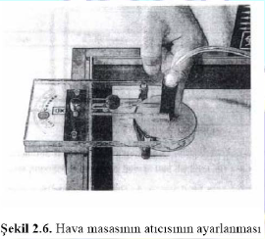

**Figure 5.6.** Adjusting the thrower

**5.2.2. Launch at Angle**

1. Place carbon paper and data sheet as the data sheet is put over the carbon paper.
2. Incline the air table by using the wooden blocks.
3. Place the launcher as close to the bottom corner of the air table as possible.
4. Fix one of the disk at any place.
5. Adjust the angle of the launcher (The angle you read from the angle is the angle with the normal of bottom side. Since you need the angle with the bottom side, you need to subtract the angle to 90.)
6. Adjust the Sparktimer frequency to decrease or increase the number of dots obtained in the experiment.
7. Make a few test launches to adjust the rubber tension. Do not use the sparktimer in these test launches, push only the compressor pedal.
8. Finally, push both compressor and sparktimer pedals simultaneously and conduct your experiment.
9. Take off the data sheet and carefully check the projection you obtained (you must obtain a projection as shown in Fig.5.7.)

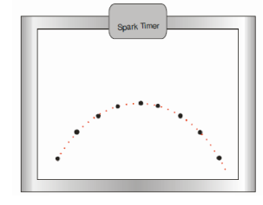

1. Circle and enumerate the dots as 0,1,2,… starting from the first dot.
2. Draw x and y-axes.
3. Draw the normal of x and y-axes for each dot to obtain the projections of the dots over x and y-axes.
4. Measure and save the flight time $t_{f}$ (total time during the motion) and the range $R$ (the horizontal distance traveled over during the motion).
5. Find the launch velocity $v_{0x}$.
6. Measure and save the maximum height. Then, calculate it by using the measured range and compare the results.
7. Measure and save the range. Then, calculate it by using the range formula and compare the results.

# 6. CONSERVATION OF ENERGY

|  |  |
| --- | --- |
| **Equipment :** | Pulley, 2 optic gates, mass hanger and mass set, air rail , air pump |
| **Purpose :** | Studying law of conservation of energy |

**6.1. Experimental Principle**

In mechanics it is natural that we should be concerned primarily with the various mechanical forms of energy. It is convenient to distinguish between two types – *potential energy* and *kinetic energy*.

The energy that a body has depending on its position or configuration is called *potential energy*. The measure of the potential energy, *U* is the work done against gravity in lifting the body. The upward force required is equal to the weight of body, and the work done in lifting the body through a height *h* is given by;

$U=mgh$ (1)

*Kinetic energy* is the energy a body possesses depending on its motion. To find the kinetic energy, which a body has, we consider the work, which must be done on the body in order to give it its speed. The work *W* done on the body of mass *m*, which initially at rest is

$W=Fx$ (2)

where *F* is the force applied to the body and *x* is the displacement. By Newton’s second law *F=ma*; thus the work is equal to *max*. Since the acceleration of the body is constant and *v*0=0,

(3)

If we substitute Eq.3 with Eq.2 and recall that the work done appears as kinetic energy, we have

$K=\frac{1}{2}mv^{2}$ (4)

Much of physics involves the relationships among the many forms of energy and the transformations from one to another. The study of these transformations has led to the statement of a very important principle, known as the *law of conservation of energy*: *Energy cannot be created or destroyed; it may be transformed from one form to another, but the total amount of energy never changes*.

According to the law of conservation of energy, if there are only conservative forces (no frictional force or no external force but the gravitation) acting on a body, the mechanical energy never changes. We can describe the mechanical energy, *E* as sum of the kinetic and the potential energies:

*E=K*+*U* (5)

**6.2. Experimental Procedure**

1. Attach some masses to mass hanger and record the total mass as *m*
2. Place the sled of mass *M* just front of the first optic gate
3. Measure the height of the *m* from the ground and record as *h*1
4. Calculate total initial energy *Ei*
5. Start up the timer which measures transition time of the sled between two optic gate
6. Turn on the air pump. When the pump begins to operate, the system will move together.
7. When the sled exits from the second optic gate, measure the height of *m* again and record as *h*2
8. Calculate the total final energy *Ef*
9. Compare your results and discuss
10. Calculate the error.

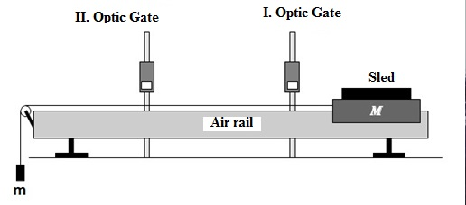

**Figure 6.1.** Experimental setup

# 7. CALORIMETER

|  |  |
| --- | --- |
| **Equipment :** | Calorimeter cup, thermometer, hot water container, metal block, power supply, joulemeter, heater, scales and weights |
| **Purpose :** | * To calculate heat capacity of the calorimeter * To determine specific heat of a solid material |

**7.1. Experimental Principle**

**7.1.1. Determination of Heat Capacity**

The heat capacity is the amount of heat required to raise the temperature of a body or substance of mass *m* 1 °C. The heat capacity can be obtained by μ = m . c relation when the specific heat of the material, which the calorimeter is made from, is known in a simple calorimeter system. To calculate the heat capacity of the system, it is acceptable to measure the masses of calorimeter, mixer, thermometer and multiply these masses with the specific heats respectively and add them all μ= ( m₁ . c₁ + m₂ .c₂ + …).

But it is not possible to determine the heat capacities of most of the calorimeters using this method. Heat capacity of such calorimeters can be determined as mentioned below.

*M* grams of water at room temperature is put into the calorimeter. Temperature of the water (*t*₁) is measured. Hot water of mass *M*ʹ and temperature of *t*₂ is added to cold water and mixed. Equilibrium temperature *θ* is öeasured. Thus, the heat gained by the calorimeter and the cold water will be,

$$Q_{1}=\left(M.c_{w}+μ\right)\left(θ-t_{1}\right)$$

and the heat lost by the hot water will be

$$Q_{2}=M^{'}.c_{w}\left(t_{2}-θ\right)$$

Assuming that, no heat loss to the surroundings (isolated system), the lost and gained heat values are equal to each other.

$$\left(M.c_{w}+μ\right)\left(θ-t_{1}\right)=M^{'}.c_{w}\left(t_{2}-θ\right)$$

Thus, heat capacity is found by the following relation

$μ=\frac{M^{'}.c_{w}\left(t_{2}-θ\right)}{\left(θ-t_{1}\right)}-M.c_{w}$ (1)

**7.1.2. Determination of Specific Heat**

The specific heat is the amount of heat required to raise the temperature of a unit mass of a substance by one unit temperature interval, that is, to raise 1 gram or 1 kilogram of a substance 1 degree Celsius. The CGS and MKS units of specific heat is cal/g°C and J/kg°C, respectively.

Experimental set up consists of a power supply, a joulemeter, a heater, a thermometer, a calorimeter cup and a metal block is shown in Fig.7.1. Joulemeter is set to "on" mode. Metal block is placed into the calorimeter cup, heater and thermometer are inserted in the metal block. The initial temperature of the block (*t*₁) is measured. Heater is set to "on" mode by power supply. When temperature is raised at amount of 10 °C, power supply is turned off. Gained heat energy is observed by the joulemeter. Temperature will increase until thermal equilibrium is established. The final temperature of the block t₂ is measured. Assuming no heat loss to the calorimeter cup, the energy given by the heater (*E*) is equal to gained energy by metal block *Q*=*M*·*c*·Δ*t*

*E=Q , E=M*·*c*·Δ*t* and specific heat ( $J/kg°C$) can be written as,

$c=\frac{E}{M.Δt}$ (2)

Where, *E* is the electrical energy converted into the heat energy, *M* is the mass of the metal block and $∆T=T_{2}-T_{1}$ is the difference between the final and initial temperatures.

**7.2. Experimental Procedure**

**7.2.1. Determination of Heat Capacity**

1. Weigh the empty calorimeter cup (*m*1).
2. Fill the calorimeter cup with water about one-quarter of the cup and weigh it (*m*2). The mass of the water in the calorimeter cup is $M=m_{2}-m_{1}$.
3. Measure the temperature of this water (*t*₁).
4. Heat up an equal amount of water to 80 °C (*t*₂). Then mix it with the water in the calorimeter cup and wait for thermal equilibrium. When thermometer is stabilized read and record the temperature ($θ$).
5. Weigh the final mass of the calorimeter again (*m*₃) and record the mass of hot water $Mʹ=m₃-m₂$  
   .
6. Use these measured values in Eq.1, calculate the heat capacity.

**NOTE:** *cw*=1 cal/g°C

**7.2.2. Determination of Specific Heat**

1. Arrange the experimental set up shown in Fig.7.1. Place the copper block into the calorimeter cup, insert heater and thermometer into the block.
2. Turn on the joulemeter.
3. Measure the initial temperature (*t*₁).
4. Set the power supply to 12 V and turn it on. When temperature increased at amount of 10 °C, turn off the power supply. Temperature will continue to increase during several minutes. Record the temperature value when the increasing stops (*t*₂).
5. Weigh the metal block and calculate specific heat by using Eq.2.

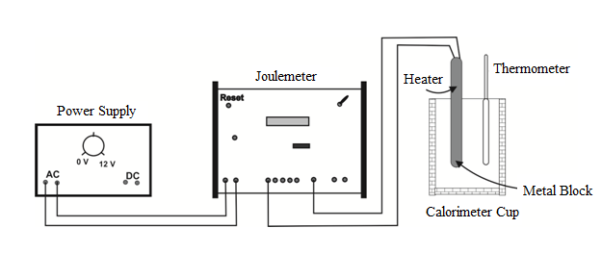

**Figure 7.1.** Experimental setup

# 8. MODULUS OF ELASTICITY

|  |  |
| --- | --- |
| **Equipment :** |  |
| **Purpose :** | Determination of the modulus of elasticity of metal bars as a function of force, thickness, width and distance between the support points |

**8.1. Experimental Principle**

If a bar of height ***b*** and width ***a***, supported at both ends by supports (separated by a distance ***L***), is subjected to a force ***Fy*** acting at its center, it behaves like a bar supported in the middle, its two ends being subjected to a force ***Fy/2*** in the opposing direction. In order to express the bending ***λ*** as a function of the modulus of elasticity ***E***, let us first consider an element of volume

*dV=dx·a·b* (1)

The upper layer of which is shortened on bending, and the bottom layer lengthened. The length of the central layer remains unchanged (neutral fibre).

On Figure 8.1, I and II denote the sides before and after deformation.

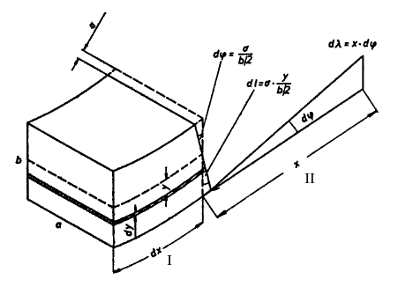

**Figure 8.1**

Using the symbols given in Fig.8.1, we obtain:

 (2)

The elastic force *dFx* which produces the extension *dL*, accordingly, is

 (3)

where *dS=a·dy* is the area of the rotated layer.

The force produces a torque of

 (4)

The sum of these torques produced by the elastic forces must be equal to the torque produced by the external force ***Fy/2***:

 (5)

from which we obtain (using Eq. 2)

 (6)

and, after integration, the total bending is obtained as

 (7)

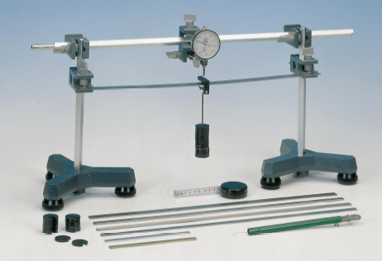

**Figure 8.2.** Experimental setup.

**8.2. Experimental Procedure**

1. Measure the bending *λ* as a function of the mass.
2. Find the “Dial Gauge” (*Fr*) from the calibration graph (see, next page).
3. On the graph, x-axis shows the values of 10- *λ* and y-axis corresponds to the “Dial Gauge” (*Fr*).
4. The “Total Force” *Fy* on the bar is the sum of the “Applied Force (*Fm*)” and the “Dial Gauge” (*Fr*).

**Table 8.1.** Bending values of the metal bar as a function of applied force (*Fm*).

|  |  |  |  |  |  |
| --- | --- | --- | --- | --- | --- |
| **Mass [g]** | **Applied Force *Fm* [N]** | **Bending *λ* [mm]** | **10- *λ* [mm]** | **Dial Gauge (*Fr*) [N]** | **Total Force *Fy* (*Fm* + *Fr*) [N]** |
| 50 |  |  |  |  |  |
| 100 |  |  |  |  |  |
| 150 |  |  |  |  |  |
| 200 |  |  |  |  |  |
| 250 |  |  |  |  |  |
| 300 |  |  |  |  |  |

1. Draw a graph of the “Bending values” (*λ*) versus “Total Force” (*Fy*); on x and y axis, respectively.
2. Calculate the slope *Fy*/ *λ* from the graph.
3. Measure the width “*a*”, the thickness “*b*” and the distance between the support points “*L*” of the metal bar.
4. Determine the modulus of the elasticity (*E*) by substituting *Fy*/ *λ* and geometric parameters of the metal bar (*a*, *b*, *L*) into Eq.7.
5. Evaluate the error calculation.

**Note: Use the correct units in the calculations.**

