EK: 2/7
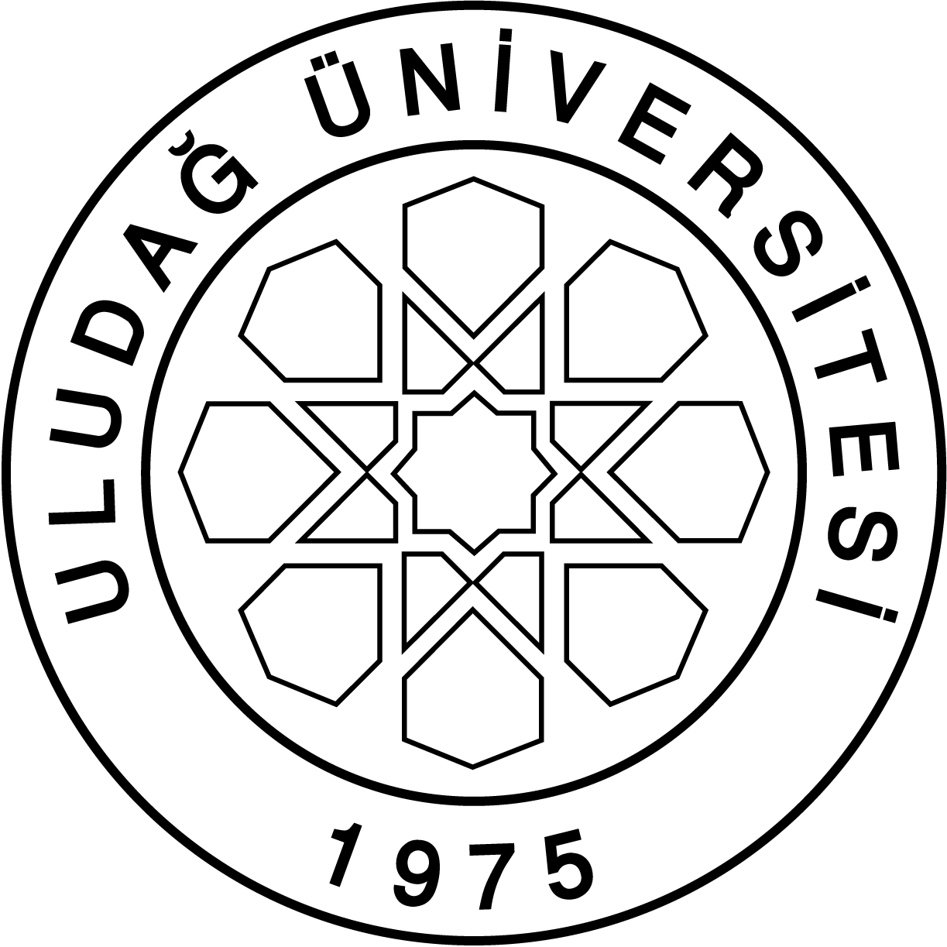
ULUDAĞ UNIVERSITY
GRADUATE SCHOOL OF NATURAL AND APPLIED SCIENCES
2017-2018 ACADEMIC YEAR COURSE PLAN
DEPARTMENT OF |  |  | DEPARTMENT OF CHEMISTRY
DEPARTMENT / PROGRAM |  |  | MASTER'SDEGREE PROGRAM
COURSE STAGE | I. TERM / FALL |  |  |  |  |  |  |  |  | II. TERM / SPRING
 | Code | Course Title |  | Type | T | U | L | Credit | ECTS | Code | Course Title | Type | T | U | L | Credit | ECTS
 | CHEM5001 | SPECTROSCOPIC METHODS IN ANALYTICAL CHEMISTRY |  | Z | 3 | 0 | 0 | 3 | 6 | CHEM5172 | SEMINAR | Z | 0 | 2 | 0 | 0 | 4
 | CHEM5003 | ADVANCED INORGANIC CHEMISTRY |  | Z | 3 | 0 | 0 | 3 | 6 | CHEM5002 | PHYSICAL CHEMISTRY OF ATOM AND MOLECULAR SYSTEMS | Z | 3 | 0 | 0 | 3 | 6
 | CHEM5025 | ADVANCED BIOCHEMISTRY |  | Z | 3 | 0 | 0 | 3 | 6 | CHEM5004 | ADVANCED ORGANIC CHEMISTRY | Z | 3 | 0 | 0 | 3 | 6
 | CHEM5191 | MA THESIS I |  | Z | 0 | 1 | 0 | 0 | 1 | OTO5000 | RESEARCH TECHNIQUES and PUBLICATION ETHICS in CHEMISTRY | C | 2 | 0 | 0 | 2 | 2
 |  |  |  |  |  |  |  |  |  | CHEM5192 | MA THESIS II | Z | 0 | 1 | 0 | 0 | 1
 | CHEM5181 | ADVANCED TOPICS IN MA THESIS I |  | S | 4 | 0 | 0 | 0 | 5 | CHEM5182 | ADVANCED TOPICS IN MA THESIS II | S | 4 | 0 | 0 | 0 | 5
 | CHEM5005 | ADVANCEDANALYTICAL CHEMISTRY |  | S | 3 | 0 | 0 | 3 | 6 | CHEM5006 | CHROMATOGRAPHIC METHODSIN ANALYTICAL CHEMISTRY | S | 3 | 0 | 0 | 3 | 6
 | CHEM5007 | SAMPLE PREPARATIONMETHODSIN ANALYTICAL CHEMISTRY |  | S | 3 | 0 | 0 | 3 | 6 | CHEM5008 | MASS SPECTROMETRIC METHODS | S | 3 | 0 | 0 | 3 | 6
 | CHEM5009 | INTRODUCTION TOCHEMOMETRICS |  | S | 3 | 0 | 0 | 3 | 6 | CHEM5010 | INTRODUCTION TO ATOMIC SPECTROSCOPY | S | 3 | 0 | 0 | 3 | 6
 | CHEM5011 | POTENTIOMETRY IN ANALYTICAL CHEMISTRY |  | S | 3 | 0 | 0 | 3 | 6 | CHEM5012 | NUCLEARANALYTICALTECHNIQUES | S | 3 | 0 | 0 | 3 | 6
 | CHEM5013 | SPECTROSCOPIC METHODS IN INORGANIC CHEMISTRY |  | S | 3 | 0 | 0 | 3 | 6 | CHEM5014 | SELECTED TOPICS INCOORDINATION CHEMISTRY | S | 3 | 0 | 0 | 3 | 6
 | CHEM5015 | THERMALANALYSIS METHODS |  | S | 3 | 0 | 0 | 3 | 6 | CHEM5016 | CYCLICVOLTAMMETRY | S | 3 | 0 | 0 | 3 | 6
 | CHEM5017 | INDUSTRIAL INORGANIC CHEMISTRY |  | S | 3 | 0 | 0 | 3 | 6 | CHEM5018 | RESEARCH METHODSIN INORGANIC CHEMISTRY | S | 3 | 0 | 0 | 3 | 6
 | CHEM5019 | ACIDS, BASES AND SOLVENTS |  | S | 3 | 0 | 0 | 3 | 6 | CHEM5020 | CHEMISTRY OF COORDINATION COMPOUNDS IN SOLUTIONS | S | 3 | 0 | 0 | 3 | 6
 | CHEM5021 | SMART POLYMERS |  | S | 3 | 0 | 0 | 3 | 6 | CHEM5022 | CHEMISTRY OFELEMENTS | S | 3 | 0 | 0 | 3 | 6
 | CHEM5023 | POROUS MATERIALS |  | S | 3 | 0 | 0 | 3 | 6 | CHEM5024 | OXIDATIONANDREDUCTIONREACTIONSIN INORGANIC CHEMISTRY | S | 3 | 0 | 0 | 3 | 6
 | CHEM5027 | PHYSIOCHEMICAL TREATMENTTECHNIQUESWASTEWATER |  | S | 3 | 0 | 0 | 3 | 6 | CHEM5026 | ADVANCED ANALYSIS TECHNIQUES OF BIOMOLECULES | S | 3 | 0 | 0 | 3 | 6
 | CHEM5029 | SEPERATION AND PURIFICATION TECHNIQUES IN ORGANIC CHEMISTRY |  | S | 3 | 0 | 0 | 3 | 6 | CHEM5028 | ELECTRONIC TEORIES IN ORGANIC CHEMISTRY | S | 3 | 0 | 0 | 3 | 6
 | CHEM5031 | SEPARATION METHODS INANALYTICAL CHEMISTRY |  | S | 3 | 0 | 0 | 3 | 6 | CHEM5030 | ION-EXCHANGERS AND THEIR PHYSICAL CHEMISTRY | S | 3 | 0 | 0 | 3 | 6
 | CHEM5033 | ADSORPTION METHODSIN ANALYTICAL CHEMISTRY |  | S | 3 | 0 | 0 | 3 | 6 | CHEM5032 | SYNTHETIC SPECIALTY POLYMERS | S | 3 | 0 | 0 | 3 | 6
 | CHEM5035 | ANALYSIS METHODS FOR WEAK ENERGY BONDS |  | S | 3 | 0 | 0 | 3 | 6 | CHEM5034 | HETEROGENEOUS CATALYSIS | S | 3 | 0 | 0 | 3 | 6
 | CHEM5037 | MOLECULAR IMPRINTED POLYMERS AND NANOBIOTECHNOLOGICAL APPLICATIONS |  | S | 3 | 0 | 0 | 3 | 6 | CHEM5036 | INTRODUCTION TO NANOTECHNOLOGY | S | 3 | 0 | 0 | 3 | 6
 | CHEM5039 | GREEN ORGANIC SYNTHESIS REACTIONS |  | S | 3 | 0 | 0 | 3 | 6 | CHEM5038 | ORGANIC REACTIONS KNOWN WITH SPECIAL NAMES | S | 3 | 0 | 0 | 3 | 6
 | CHEM5041 | DNA,RNA and PROTEIN SYNTHESIS METABOLISM |  | S | 3 | 0 | 0 | 3 | 6 | CHEM5040 | ELECTROANALYTICAL CHEMISTRY | S | 3 | 0 | 0 | 3 | 6
 |  |  |  |  |  |  |  |  |  | CHEM5042 | TRANSPORT and BIOSIGNALING in BIOLOGICAL MEMBRANES | S | 3 | 0 | 0 | 3 | 6
 |  |  |  |  |  |  |  |  |  | CHEM5044 | BIOSYNTHESIS | S | 3 | 0 | 0 | 3 | 6
 |  |  |  |  |  |  |  |  |  | CHEM5046 | HORMONAL REGULATION of METABOLISM | S | 3 | 0 | 0 | 3 | 6
 | Total Credits |  |  |  |  |  |  | 12 | 30 | Total Credits |  |  |  |  |  | 11 | 30
STAGE THESIS | III. TERM / FALL |  |  |  |  |  |  |  |  | IV. TERM / SPRING
 | CHEM5183 | ADVANCED TOPICS IN MA THESIS III |  | Z | 4 | 0 | 0 | 0 | 5 | CHEM5184 | ADVANCED TOPICS IN MA THESIS IV | Z | 4 | 0 | 0 | 0 | 5
 | CHEM5193 | MA THESIS III |  | Z | 0 | 1 | 0 | 0 | 25 | CHEM5194 | MA THESIS IV | Z | 0 | 1 | 0 | 0 | 25
 | Total Credits |  |  |  |  |  |  | 0 | 30 | Total Credits |  |  |  |  |  | 0 | 30
TOTAL CREDITS: 23 - TOTAL ECTS: 120
Not: After the student receives compulsory course of registered discipline, 3 credits of elective courses will take 2 or 3 pieces
Studentsmay takecompulsory courses of other disciplines as an elective
If the student wants to may choose one selective course from another department with the endorsement of the supervisor

